Empowering Executives as They Transition from Peak Career to Peak Retirement
Author: Jake Weatherford CFP, MBA

Executive Summary: Navigating the Executive Transition with Precision
At the highest levels of leadership, retirement is not merely an exit. It's a strategic inflection point. For executives who have built careers on foresight, decisiveness, and vision, the transition from active leadership to life beyond the C-suite requires the same precision they once applied to major corporate transformations.
This paper explores how to architect a seamless shift from peak career to peak retirement—preserving influence, legacy, and fulfillment without compromising strategic clarity or personal direction.

1. Redefining Influence: Sustaining Strategic Impact Beyond the C-Suite
Stepping down does not mean stepping away. Executives must reframe retirement not as withdrawal, but as realignment of influence.
Channels of Continued Impact:
- Advisory and Board Roles: Governance positions in industries where insight remains sharp.
- Mentorship and Thought Leadership: Passing on operational wisdom through selective mentorship or high-level consulting.
- Purpose-Driven Ventures: Channeling capital and time toward philanthropy, civic engagement, or venture investment.
This next chapter is about staying engaged where impact still matters—with a blueprint that reflects values, not just valuations.
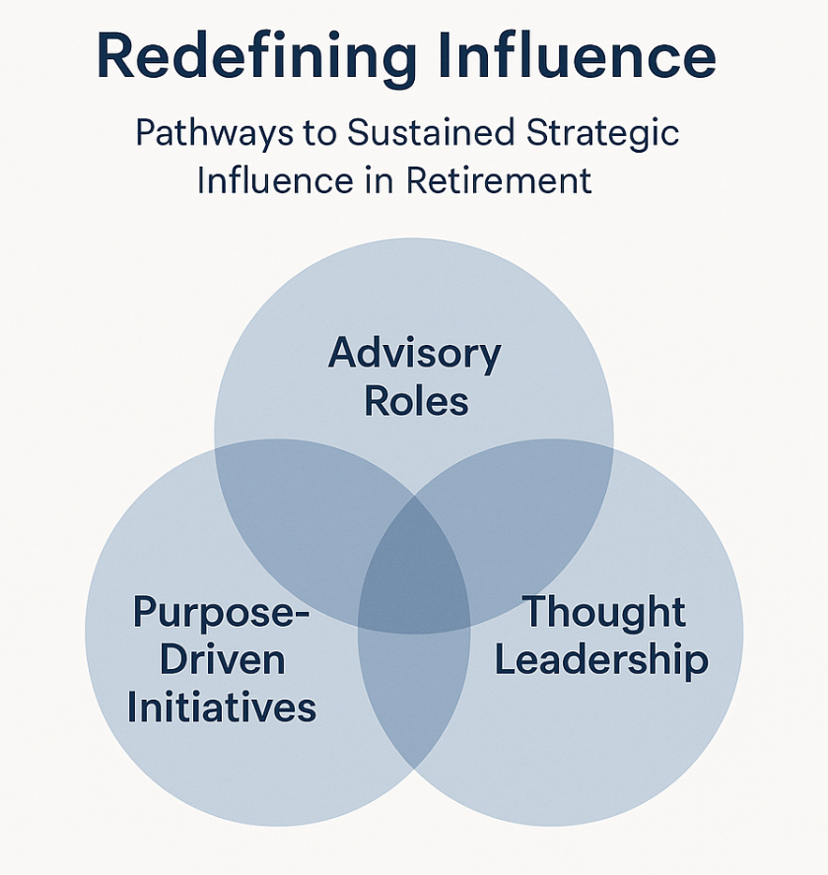

2. Portfolio Optimization: Aligning Wealth Strategy with Vision
Executives are not passive investors; they require a wealth strategy that reflects their analytical mindset, forward-thinking approach, and commitment to long-term value creation.
Key Strategic Levers:
- Asset Allocation: Balancing growth and liquidity through strategic diversification.
- Public & Private Markets: Incorporating private equity, venture capital, and impact investing aligned with personal vision.
- Cash Flow Design: Engineering income streams that support agility while remaining tax-efficient.
- Concentration risk assessment: Many executives have large concentrations of stock options which should be evaluated as a part of the holistic portfolio.
The goal: Ensure capital performs with the same efficiency and intentionality as the executive career it underwrites.
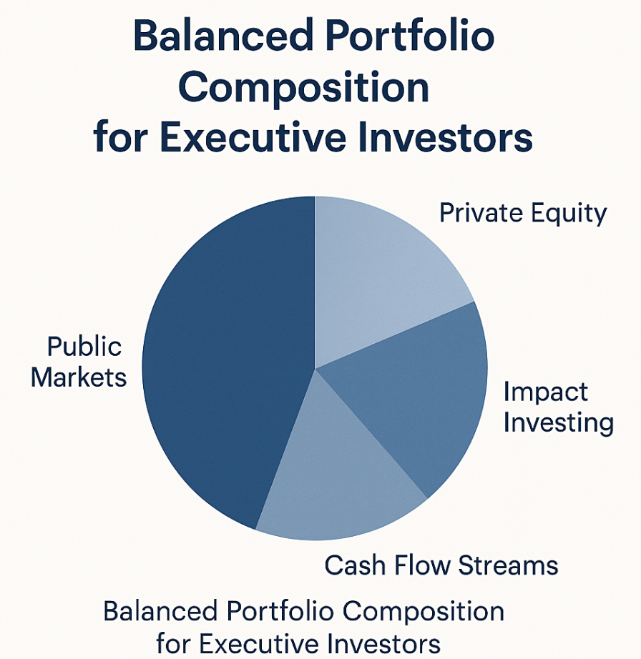

3. Legacy and Estate Structuring: Beyond Wealth Transfer
Legacy is not just about inheritance—it’s about intention. The objective is to perpetuate influence, values, and decision-making frameworks across generations.
Strategic Legacy Tools:
- Multi-Generational Structures: Trusts, governance frameworks, and family office principles.
- Values-Based Philanthropy: Charitable vehicles that express both financial prudence and personal conviction.
- Succession Engineering: Clear pathways for business holdings and private investments.
It’s not about passing the baton; it’s about embedding vision in systems that endure.
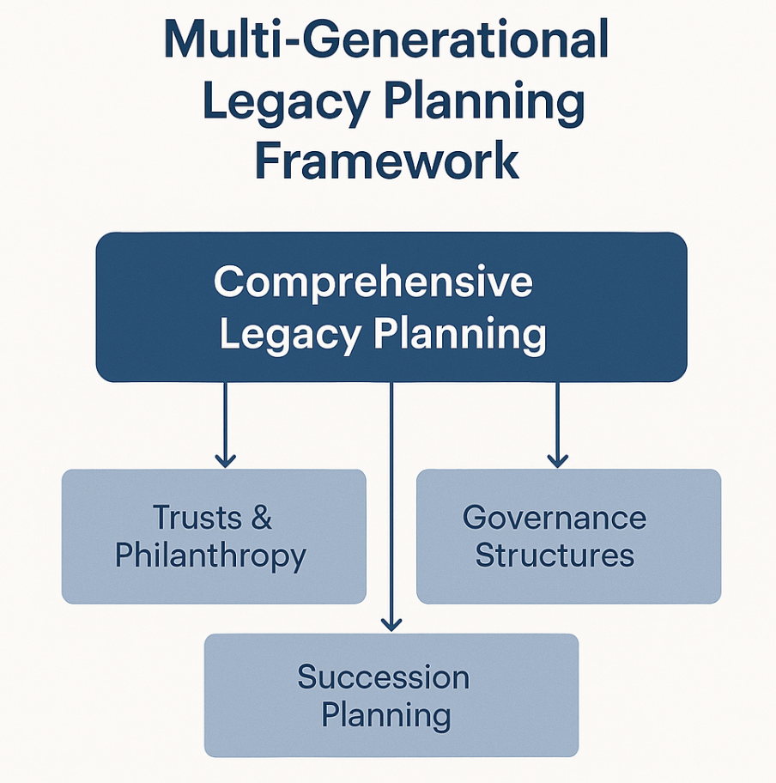

4. Beyond Financial Planning: A Holistic Partnership
Executives require strategic partners who understand complexity, anticipate inflection points, and offer solutions that transcend investment products.
Strategic Services That Matter:
- Business Succession Design: Exit planning that protects equity and organizational integrity.
- Curated Market Intelligence: Insights tailored to global shifts, regulatory dynamics, and opportunity cycles.
- Executive Risk Architecture: Concentrated stock mitigation, deferred comp optimization, and scenario modeling.
Financial strategy must evolve into a full-spectrum advisory model that aligns with the demands of executive decision-making.

5. Designing a Retirement that Optimizes Time, Wealth, and Fulfillment
Retirement is a resource reallocation exercise: of time, capital, and attention. Executives should approach it as a redesign of how they engage with the world.
Pillars of Strategic Life Planning:
- Freedom to Focus: Enabling personal pursuits and passion projects with intentional capital design.
- Professional Optionality: Structuring opportunities to stay involved through boards, ventures, or strategic counsel.
- Intellectual Engagement: Access to networks, think tanks, and learning ecosystems.
A well-executed retirement plan becomes a platform for continued relevance—on the executive’s terms.

Conclusion: Elevating Executive Retirement to Its Full Potential
This isn’t the end of a career. It’s the next stage of strategic influence. With a disciplined framework, executives can transition deliberately, maintain their intellectual edge, and build a legacy that lasts.
The opportunity is not to slow down—but to redirect. Not to retire from something, but to retire into something.
This paper is intended as a strategic lens for executives preparing for transition. It reflects the level of precision, scope, and insight that leadership demands when designing what comes next.

